**LAB EXERCISE – 8**

* RAMAKRISHNAN ILANGHOVAN (23BCE1489)

***CODE:***

<!DOCTYPE html>

<html lang="en">

  <head>

    <meta charset="UTF-8" />

    <meta name="viewport" content="width=device-width, initial-scale=1.0" />

    <title>Document</title>

    <script>

*// quest 1*

      a = prompt("enter 1st num")

      b = prompt("enter 2st num")

      alert(`

      sum: ${a+b}

      diff: ${a-b}

      prod: ${a*b}

      div: ${a/b}

      mod: ${a%b}

      `)

    </script>

  </head>

  <body>

  </body>

</html>

***OUTPUT:***

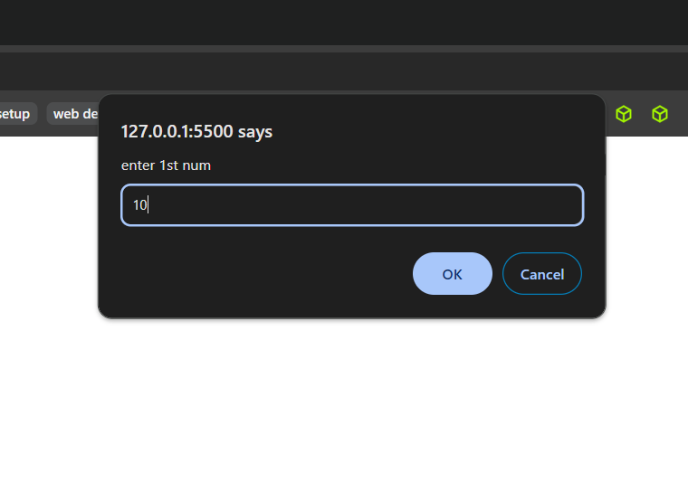

***CODE:***

<!DOCTYPE html>

<html lang="en">

  <head>

    <meta charset="UTF-8" />

    <meta name="viewport" content="width=device-width, initial-scale=1.0" />

    <title>Document</title>

    <script>

*// quest 2*

      age = prompt("enter your age")

      alert(`${age >= 18 ? "Eligible" : "Not Eligible"}`)

    </script>

  </head>

  <body>

  </body>

</html>

***OUTPUT:***

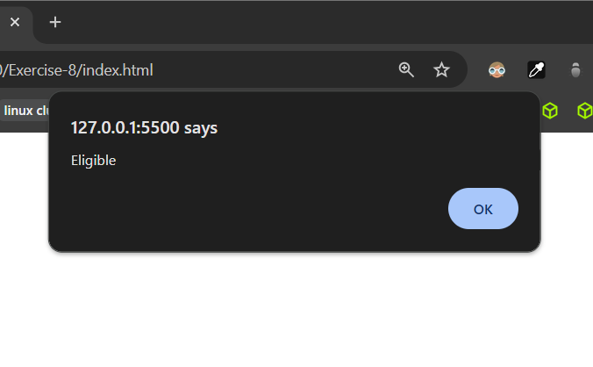

***CODE:***

<!DOCTYPE html>

<html lang="en">

  <head>

    <meta charset="UTF-8" />

    <meta name="viewport" content="width=device-width, initial-scale=1.0" />

    <title>Document</title>

    <script>

*// quest 3*

      answer = confirm("are you a student?")

      alert(answer)

    </script>

  </head>

  <body>

  </body>

</html>

***OUTPUT:***

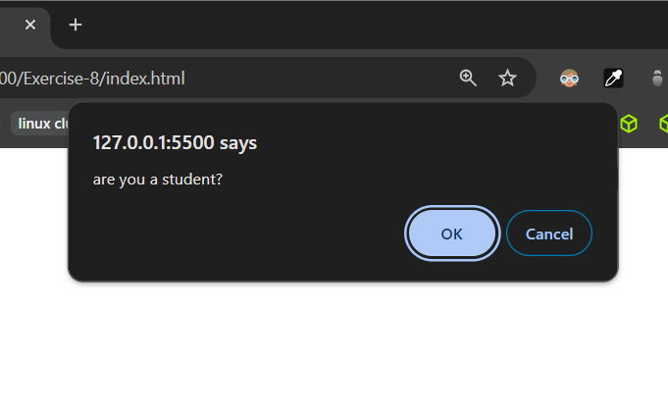

***CODE:***

<!DOCTYPE html>

<html lang="en">

  <head>

    <meta charset="UTF-8" />

    <meta name="viewport" content="width=device-width, initial-scale=1.0" />

    <title>Document</title>

    <script>

*// quest 4*

      hrs = prompt("number of hours worked")

      cost = prompt("enter the material cost")

      alert(`total cost is ${(45*hrs) + cost}`)

    </script>

  </head>

  <body>

  </body>

</html>

***OUTPUT:***

***CODE:***

<!DOCTYPE html>

<html lang="en">

  <head>

    <meta charset="UTF-8" />

    <meta name="viewport" content="width=device-width, initial-scale=1.0" />

    <title>Document</title>

  </head>

  <body>

*<!-- quest 5 -->*

    <div id="box" style="display: flex; align-items: center; flex-wrap: wrap; width: 100%; margin-top: 20px;"></div>

    <script src="./index.js"></script>

  </body>

</html>

*// quest 5*

name = prompt("enter your name");

regno = prompt("enter your reg no");

document.write(

  `<span style="font-weight: 500; border:3px solid red; padding: 5px; margin: 10px">${regno}</span>`

);

const box = document.getElementById("box");

box.innerHTML = `<span style="border: 2px solid black; padding: 10px; font-weight: bold; font-size: 20px; text-align: center; color: red; display: inline-block; margin: 10px;"> *${name}* </span>`;

***OUTPUT:***

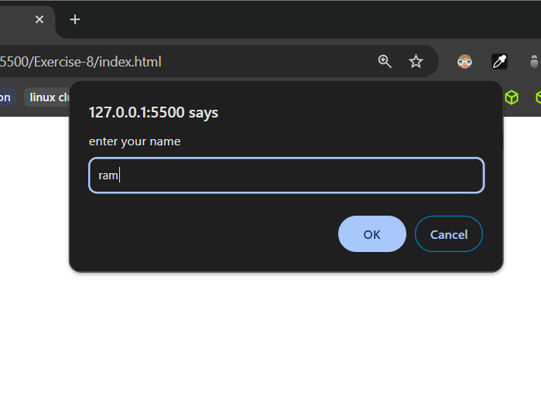

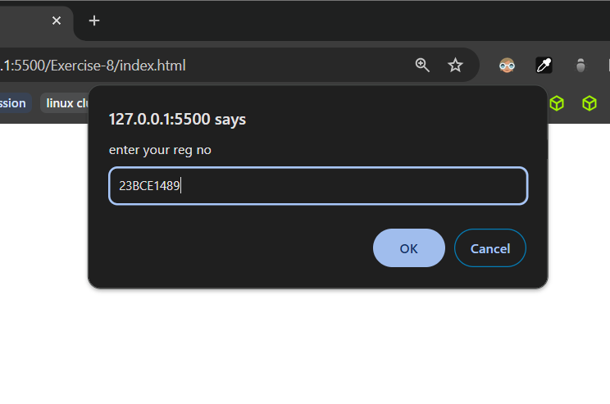

***CODE:***

<!DOCTYPE html>

<html lang="en">

  <head>

    <meta charset="UTF-8" />

    <meta name="viewport" content="width=device-width, initial-scale=1.0" />

    <title>Document</title>

  </head>

  <body>

*<!-- quest 6 -->*

    <label for="adults">Adults (₹10 each)</label><br>

    <input type="text" name="adults" id="adults"><br>

    <label for="children">Children (₹5 each)</label><br>

    <input type="text" name="children" id="children"><br> <br>

    <button id="btn">Total</button><br>

    <div id="total" style="margin-top: 5px; height: 20px; width: 50px; border: 1px solid black;"></div>

    <script src="./index.js"></script>

  </body>

</html>

*// quest 6*

const btn = document.getElementById("btn");

const total = document.getElementById("total");

btn.addEventListener("click", () => {

  const adults = document.getElementById("adults").value;

  const children = document.getElementById("children").value;

  total.textContent =

    (parseInt(adults) || 0) * 10 + (parseInt(children) || 0) * 5;

});

***OUTPUT:***

